

Circuit Playground Express

*Introducing the Circuit Playground Express*

In the previous lesson, we explored how electrical current flows using a battery. In this lesson, we introduce the Circuit Playground Express, and use it in the simplest way possible, by using a 3.3v power-supply pad and a GND pad to replace the battery from the previous lesson.

1. Introducing the Circuit Playground Express

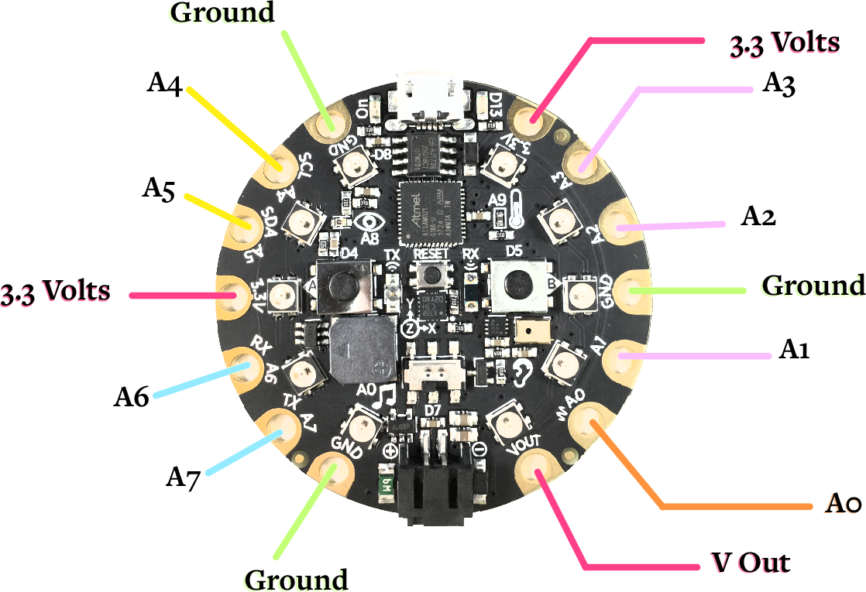

The first thing we'll look at are the pads, which can be used in a large number of ways:

* Ground (labeled GND on the Circuit Playground Express): These pads fulfil the same role as the "-" end of the previous lesson's 9v battery. All of the circuits we build using the Circuit Playground Express will end at one of the three GND pins. Note that these pins are completely interchangeable with each other - they are actually connected internally, so there's literally no difference between them.
* 3.3 Volts and VOUT: These are the Circuit Playground Express's power supply pads, and play the same role as the "+" pad on the 9v battery; they are the origin from which current flows to power components requiring a relatively high voltage. The 3.3v pads are regulated so that they will always provide power at 3.3v. The VOUT pad is not regulated, so it provides whatever current is powering the Circuit Playground Express (this can vary from 3.5v to 6.5v, which are the minimum and maximum voltages that the Circuit Playground Express can handle).
* A0 - A7 - These pads are incredibly versatile, and can be programmed using MakeCode to (among other things) power up and down, detect whether there is current flowing to them, and detect a finger touching them. We can use all of these capabilities in our MakeCode programs.

One of the very special things about the Circuit Playground Express is that it also includes a number of onboard sensors that can be incorporated into your programs. In later lessons, we will explore some of the things that you can accomplish with these onboard sensors (and how to add new sensors of your own!).

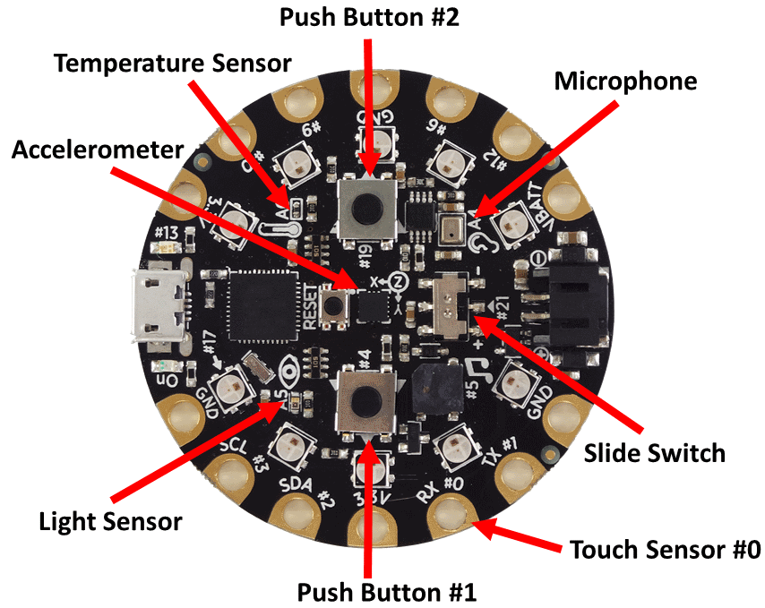

2. Current flow with the Circuit Playground Express

As mentioned in the previous lesson, one of the biggest challenges in students' developing a strong understanding of how their Circuit Playground Express projects work is ensuring that they understand current flow. The fundamental principle they really need to understand is that current originates from a pad (3.3v or VOUT in this lesson's circuit), travels through the various components (wires, LEDs, buttons, resistors, motors, etc.), and finally arrives at a GND pin. To practice this concept and introduce the always-on 3.3v and VOUT pads, replace the battery in the previous lesson's circuit with the Circuit Playground Express, as illustrated.

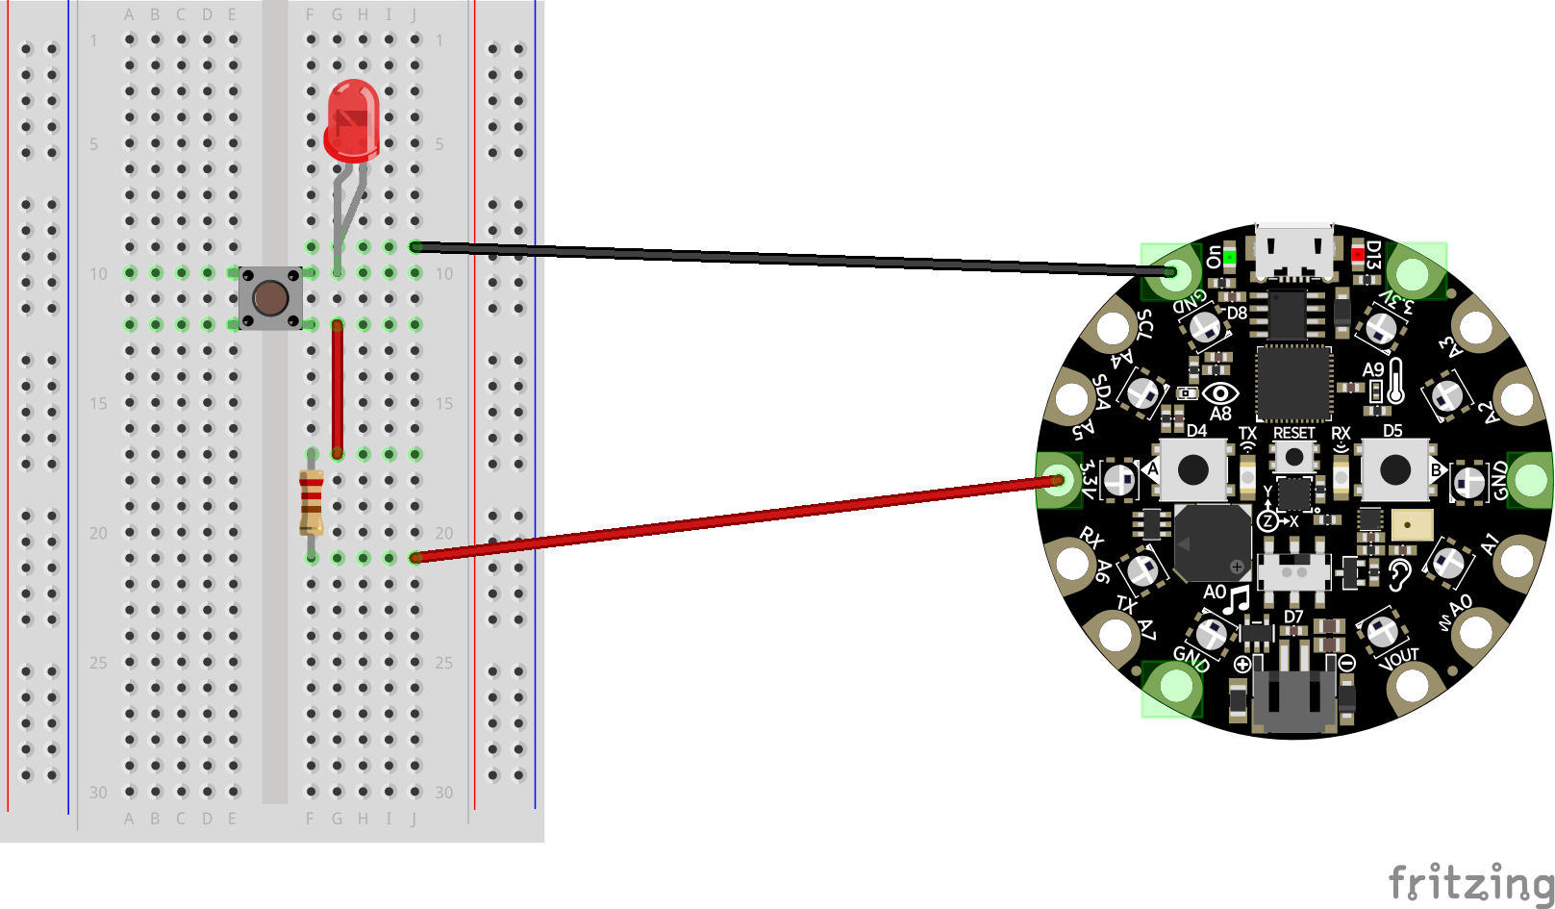

This circuit should work just the same as it did with the 9v battery, though you'll likely notice that the LED is somewhat dimmer; a 9v battery provides a bit more power than the Circuit Playground does.

It is recommended that you have your students draw this circuit for themselves, and trace out the path that current is taking from the 3.3V/VOUT pad through each component and back to GND to ensure that they understand the basics of current flow, which will be very important in understanding more complex projects.